Software Detail Design

for

Document Management System

Prepared by Group 3

March 31, 2023

1. **MODEL DIAGRAMS**
2. **Sequence Diagram**
3. **Diagram

   Description automatically generated**Adding a new document
4. Calendar

   Description automatically generatedLogging and changing password
5. Diagram

   Description automatically generatedApproving document
6. **Activity Digram**
7. Login

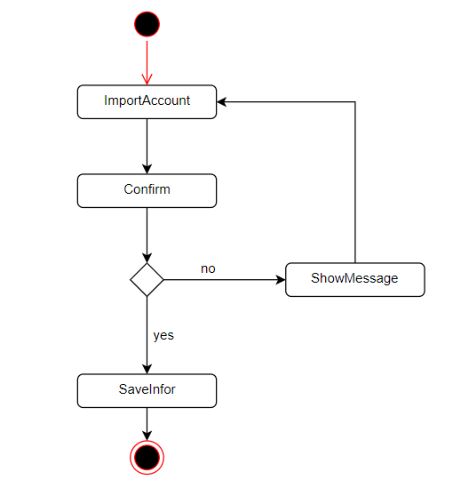

1. Logout

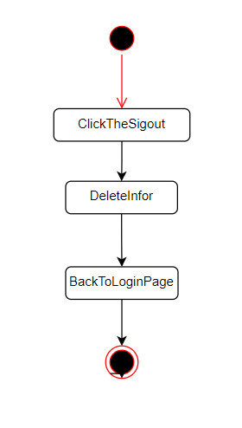

1. Update document

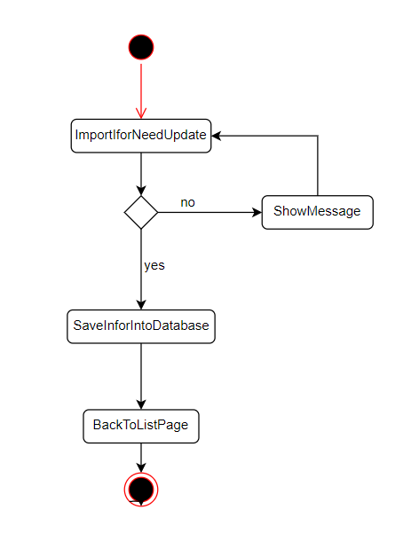

1. Delete documnet

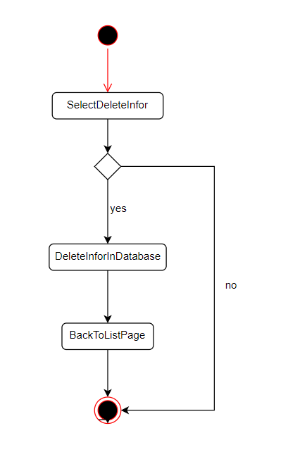

1. **State Diagram**

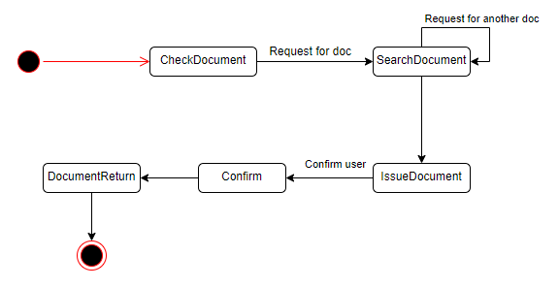

1. 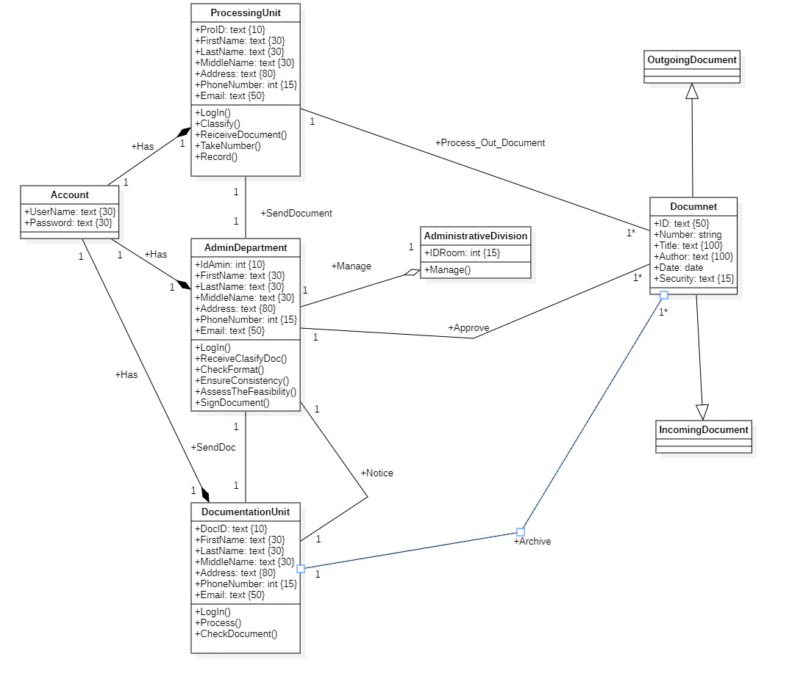**Class Diagram**
2. **Chart, bubble chart

   Description automatically generatedE-R DIAGRAM**
3. **Diagram

   Description automatically generatedDATABASE**